Project Design Phase-II

Data Flow Diagram & User Stories
Date | 31January 2025
Team ID
Project Name | Advancing Nutrition Science through GeminiAI (NutriGen AI)
Maximum Marks | 4Marks

Data Flow Diagrams:

Introduction & User Problem
The document begins by highlighting the core problem NutriGen aims to solve: Many individuals struggle with creating healthy and satisfying meal plans that align with their specific needs and preferences.
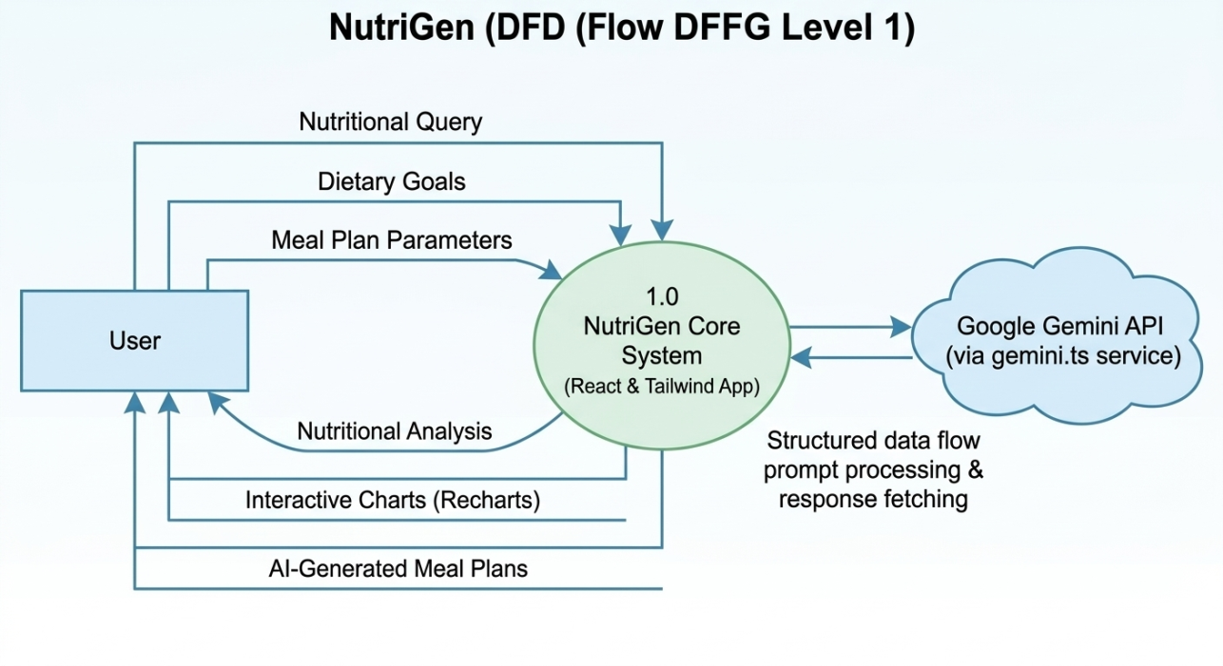

Core Scenarios (User Stories)
1. Tailored Meal Planning
- The User Struggle: Creating healthy, satisfying meal plans that meet specific needs and preferences is difficult for many.
- The NutriGen Solution: Addressing this challenge by generating personalized meal plans based on user input. Users can provide information regarding:
  - Dietary Restrictions
  - Allergies
  - Health Conditions
  - Activity Levels
  - Taste Preferences
- The Outcome: The AI crafts a week-long meal plan complete with recipes and grocery lists, ensuring nutritional balance, variety, and enjoyment.
2. Dynamic Nutritional Insights
- The User Struggle: Understanding the nutritional content of food is essential for making healthy choices, but often difficult to calculate dynamically.
- The NutriGen Solution: Providing users with dynamic nutritional insights about their meals and snacks. By inputting food items, users instantly receive detailed information on:
  - Macronutrients (protein, fat, carbohydrates)
  - Micronutrients (vitamins, minerals)
  - Calorie content
- The Outcome: Empowers users to make conscious decisions about their food intake and accurately track progress toward nutritional goals.
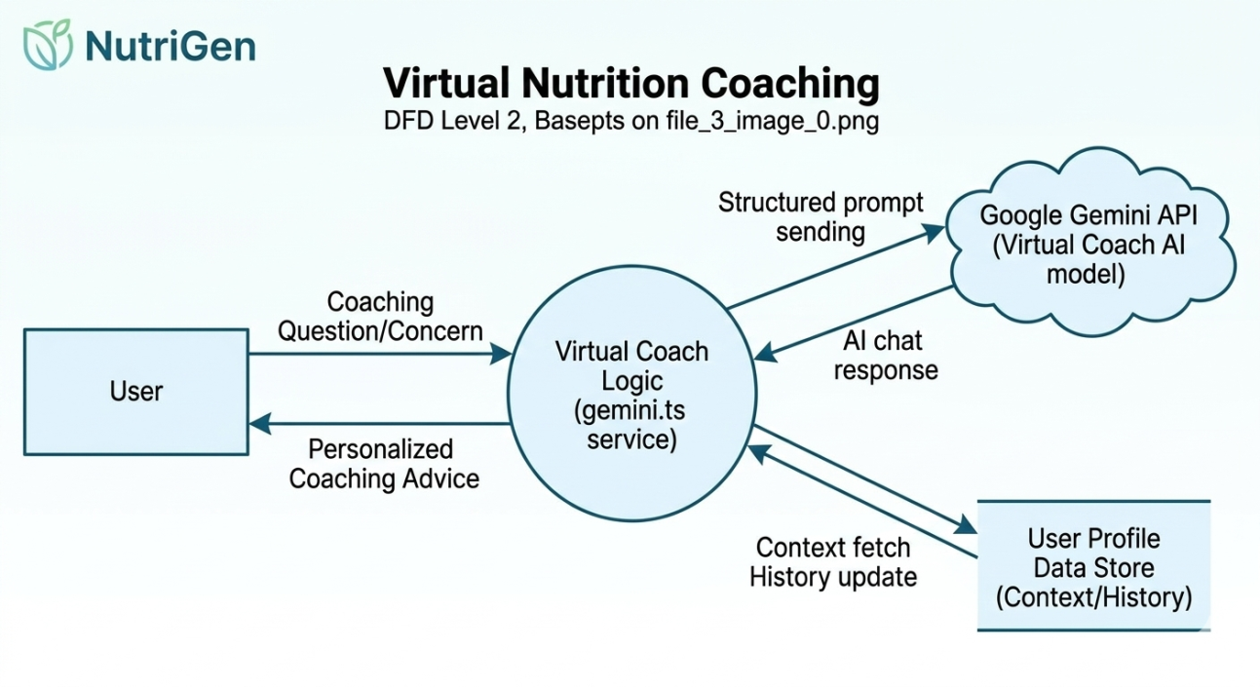
3. Virtual Nutrition Coaching
- The User Struggle: Receiving personalized guidance from a nutrition expert is often costly and time-consuming.
- The NutriGen Solution: Democratizing access to nutritional expertise by offering virtual nutrition coaching. The AI acts as a virtual coach, providing:
  - Personalized advice
  - Answers to specific questions
  - Support throughout the wellness journey
- The Outcome: This interactive coaching experience helps users stay motivated, make sustainable lifestyle changes, and achieve long-term health improvements.

